ENROLMENT FORM – HLTINFCOV001

My USI number is:

IMPORTANT: Please make sure you have your Unique Student Identifier (USI) number when enrolling. Why? If you do not supply a USI the RTO cannot supply your certificates. (Refer: Clause 3.6b - SRTO 2015 ) If you have not yet obtained a USI you can apply for it directly at https://www.usi.gov.au/students/create-your-usi/ on computer or mobile device.
Please complete all details below - ALL sections with this symbol MUST be filled in.
*SECTION 1 - PERSONAL DETAILS:
Title | Family Name | Given Name | Other Name (middle name)
 |  | ☐ Female ☐ Male ☐ Other
Date of Birth |  | Gender
*Contact Details: (Give at least one phone number)
Home Phone | Work Phone |  | Mobile Phone
 |  | ☐ Phone ☐ Email ☐ Both
Email Address (if applicable) |  | Preferred Contact Method
*Emergency Contact:
Person | Relationship | Home / Work or Mobile Phone
*Address Details:
Unit | Number | Street | Community/Town/City/Suburb | State & Postcode
Postal Address:
PO Box | Community/Town/City/Suburb | State & Postcode
*Indigenous Status:
☐ Yes, Aboriginal  ☐ Yes, Torres Strait Islander | ☐ Yes, both Aboriginal & Torres Strait Islander  ☐ No, neither Aboriginal & Torres Strait Islander
*Country of Birth:
☐ Australia | ☐ Other, please specify:

*Language spoken at home:
☐ English | ☐ Other, please specify:
*School Level - education:
☐ Year 8 or below | ☐ Did not go to school | ☐ Completed year 11
☐ Year 9 or below | ☐ Completed year 10 | ☐ Completed year 12
☐ Currently at secondary school
*Disability:
Note: The information you provide is confidential and will only be used by CARHDS to help you with your learning.
☐ Vision | ☐ Learning | ☐ Medical Condition
☐ Hearing/Deaf | ☐ Physical | ☐ Acquired Brain Impairment
☐ Intellectual | ☐ Mental Illness | ☐ Other
*SECTION 2 - EDUCATION DETAILS:
Please tick whether you have completed or partially completed any of the following?
☐ Bachelor Degree or Higher Degree
☐ Advanced Diploma or Associate Degree
☐ Diploma (or Associate Diploma)
☐ Certificate IV (or Advanced Certificate/Technician)
☐ Certificate III (or Trade Certificate)
☐ Certificate II
☐ Certificate I
☐ Certificates other than above, please specify:
*Reason for study:
Of the following categories, which BEST describes your main reason for undertaking study.
☐ It was a requirement of my job | ☐ To get into another course of study
☐ I wanted extra skills for my job | ☐ For personal interest
☐ To get a better job or promotion | ☐ For self-development
☐ To try for a different career | ☐ Other reasons:

*SECTION 3 - EMPLOYMENT DETAILS:
Name of Organisation/Employer:
What is your occupation?
Of the following categories, which BEST describes your current employment?
☐ Full-Time | ☐ Part-Time | ☐ Casual | ☐ Apprentice | ☐ Trainee
☐ Other, please specify:
SECTION 4 - ENROLMENT DETAILS:
Unit Code: HLTINFCOV001 | Unit Name: Comply with infection prevention and control policies and procedures
SECTION 5 – CREATE A MOODLE CLOUD ACCOUNT:
To access the online parts of the HLTINFCOV001 training you will need to create a Moodle cloud account as follows:
Step 1: Go to https://new-normal.moodlecloud.com
Step 2: Create new account under “is this your first time here?”
Step 3: A Privacy Notice will appear. Scroll to the bottom of the screen and click “Next”
Step 4: A Cookies Policy will appear. Again scroll down the page and click “Next”
Step 5: Consent at both checkboxes is required then click “Next”
Step 6: New Account & fill in your details. Hint – use your email address as your username. Click “Create my new account”. A confirmation email will be sent to the address you have entered.
Step 7: Check your email and click the confirmation link in the email. You should see a screen like the one below. Click “continue”
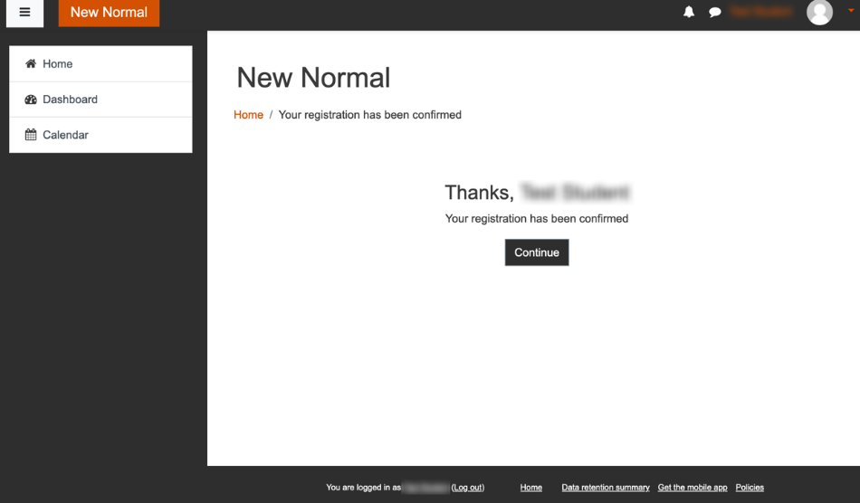
Step 8: Click on the course link: ‘HLTINFCOV001 Comply with infection prevention and control policies and procedures’.
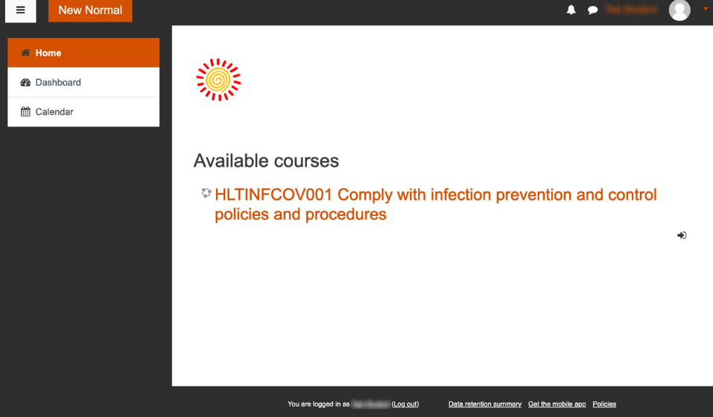
Step 9: Enrol in the course by clicking “Enrol me”.
You are now ready to start the course.

*PARTICIPANT DECLARATION: - use an electronic signature if available or you will be asked to sign this at the workshop session.
Please read the following statement carefully, tick the boxes and add the date below:
Your rights and responsibilities as a student at CARHDS:
☐ I have been informed about my course dates and times. ☐ I authorise CARHDS staff to get medical assistance for me if I need it. ☐ I consent to CARHDS searching on my behalf to locate my USI on the USI portal system. CARHDS may use my photograph for public relations and marketing. ☐ YES ☐ NO

*PARTICIPANT’S SIGNATURE: | DATE:

Educator to print, sign and date:
Educator’s Name:
EDUCATOR’S SIGNATURE: | DATE:

Upload this Enrolment Form to your new-normal moodlecloud account or email to reception@carhds.org.au if you are unable to upload.

OFFICE USE ONLY
VETtrak Data Entry Date: ___ / ___ / ______ Staff Initial: _______________ Participant VETtrak No.:_________________

LL&N Assessment Completed? ☐ Yes ☐ No Staff initial: ____________

